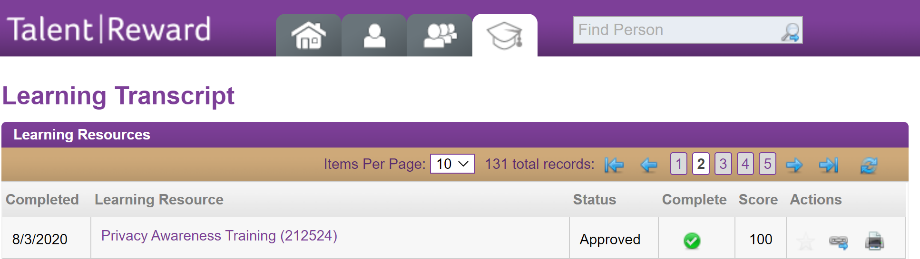







The above courses from my (Brian Tuberty) Learning Center transcript appear to address the Audit questions around security controls.

Some screen shots from training (below):

Machine generated alternative text:
Privacy & Security of Personal Information 
Professional practices to protect confidential data: 
• Use and disclose only the minimum necessary amount of PHI or Pll to do your job 
o Remove all identifiers whenever possible 
o Share PHI or Pll with the minimum authorized number of people inside or 
outside CVS Health 
o View only the minimum amount of information required 
• Disclose PHI or Pll to a third party only with appropriate written authorization 
• Appropriately dispose of unneeded copies of documents containing PHI or Pll 
• Keep confidential information out of sight 
o Keep information in a locked file cabinet or desk drawer 
o Never leave PHI or Pll active on computers, in fax machines or generally 
accessible areas 
• Unless required by law or otherwise granted an exception by the Privacy Office, ensure PHI 
and Pll is encrypted when transmitted or transported outside the Company 
• Violating these privacy requirements will result in severe disciplinary actions 
NOTE: Should you suspect PHI or Pll has been compromised, contact the Privacy 
Office immediately at 866-443-0933 or Privacy.Officer@CVSHealth.com. 

Machine generated alternative text:
Financial Integrity 
Maintaining integrity in financial affairs is significant 
in order to build trust with shareholders. CVS Health 
is required to: 
• Ensure certain Company leaders certify to the truth 
and accuracy of Company financial statements 
• Maintain appropriate financial controls 
• Report significant fraud 
• Maintain detailed and accurate records of the 
Company's business operations 
If you have a role in public financial communications, 
make sure disclosures are full, fair, accurate, timely 
and understandable. 

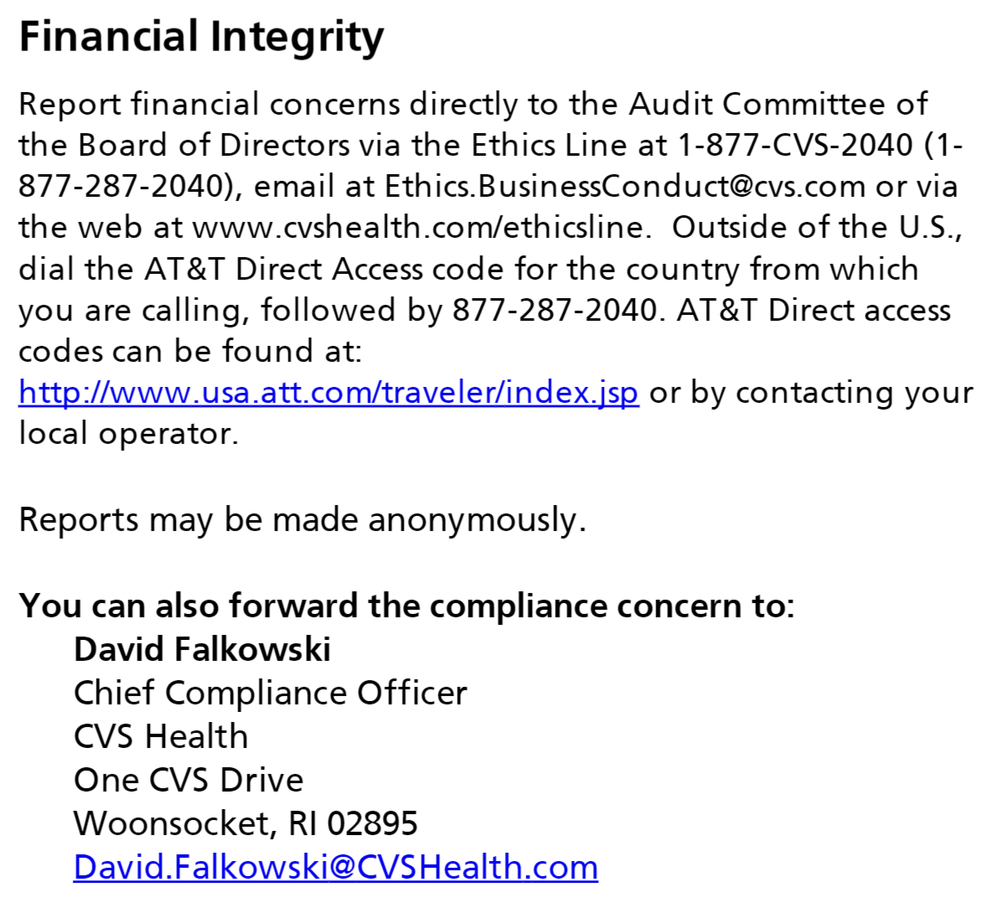

Machine generated alternative text:
Confidential & Proprietary Information 
Confidential and proprietary information includes, 
but is not limited to: 
Company policies or procedures 
Technical advances 
Customer lists 
Acquisition information 
Divestitures and financial data 

Machine generated alternative text:
Medicare 
Compliance programs help prevent, detect and correct noncompliance and fraud, waste and 
abuse. The Centers for Medicare and Medicaid Services (CMS) require that an effective 
compliance program include the seven core elements described below. They include: 
1. 
2. 
3. 
4. 
5. 
6. 
7. 
Written Policies, Procedures and Standards of Conduct 
Compliance Officer / Committee and High Level Oversight 
Effective Training and Education 
Effective Lines of Communication 
Well Publicized Disciplinary Standards 
Effective Systems for Routine Monitoring, Auditing and Identification of Compliance Risks 
Procedures and System for Prompt Response and Compliance Issues 
Click to review CMS Medicare Compliance and Fraud, Waste, and Abuse information: 
CMS Medicare Parts C and D General Compliance 
Combating Medicare Parts C and D Fraud, Waste, an Abuse 
Click this link 
As a reminder, CVS Health Medicare policies that support the Medicare Compliance Program 
are available on the CVS Health Policy and Procedure Portal, AetNet, and Aetna.com. 

Machine generated alternative text:
LESSON PAGE 16 
Knowledge Check 
Select the correct answer. 
You discover an unattended email address or fax machine in your office receiving beneficiary appeals requests. You suspect no one 
is processing the appeals. What should you do? 
o 
O 
o 
B. 
D. 
E. 
Contact law enforcement 
Nothing 
Contact your compliance department (via compliance hotline or other mechanism) 
Wait to confirm someone is processing the appeals before taking further action 
Contact your supervisor 
CORRECT 
ANSWER 
c 
End of Page 
SCORE 
CORRECT FEEDBACK 
Correct! 
Select the "NEXT" button to continue. 
INCORRECT FEEDBACK 
Incorrect. The correct answer IS C. 
Select the "NEXT" button to continue. 

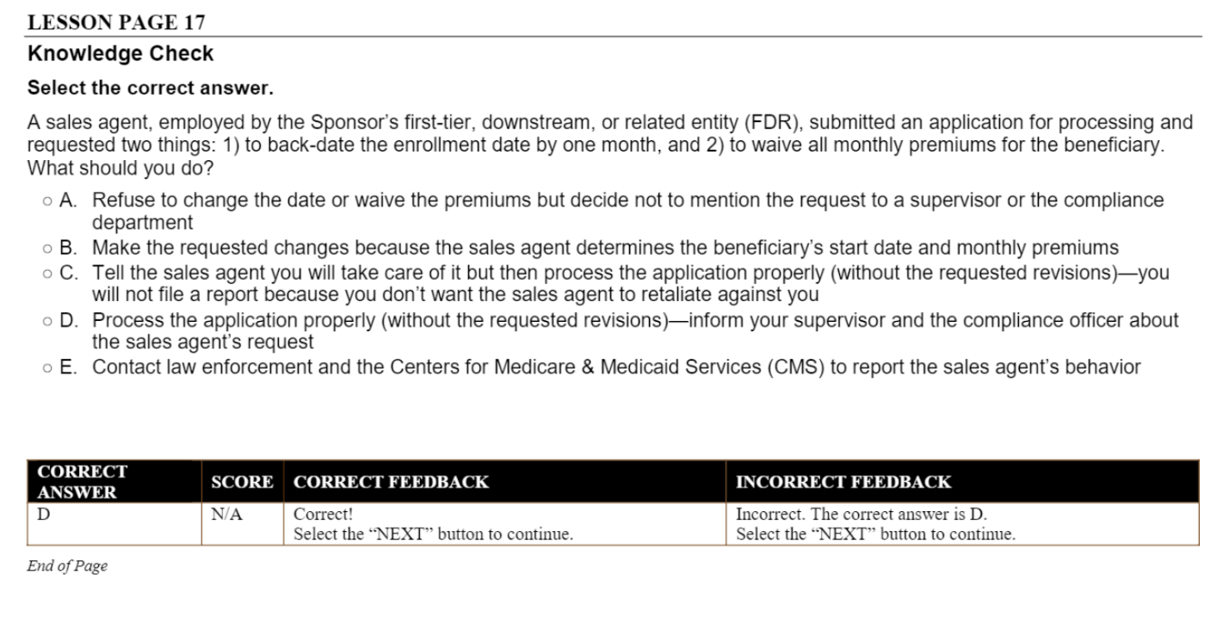

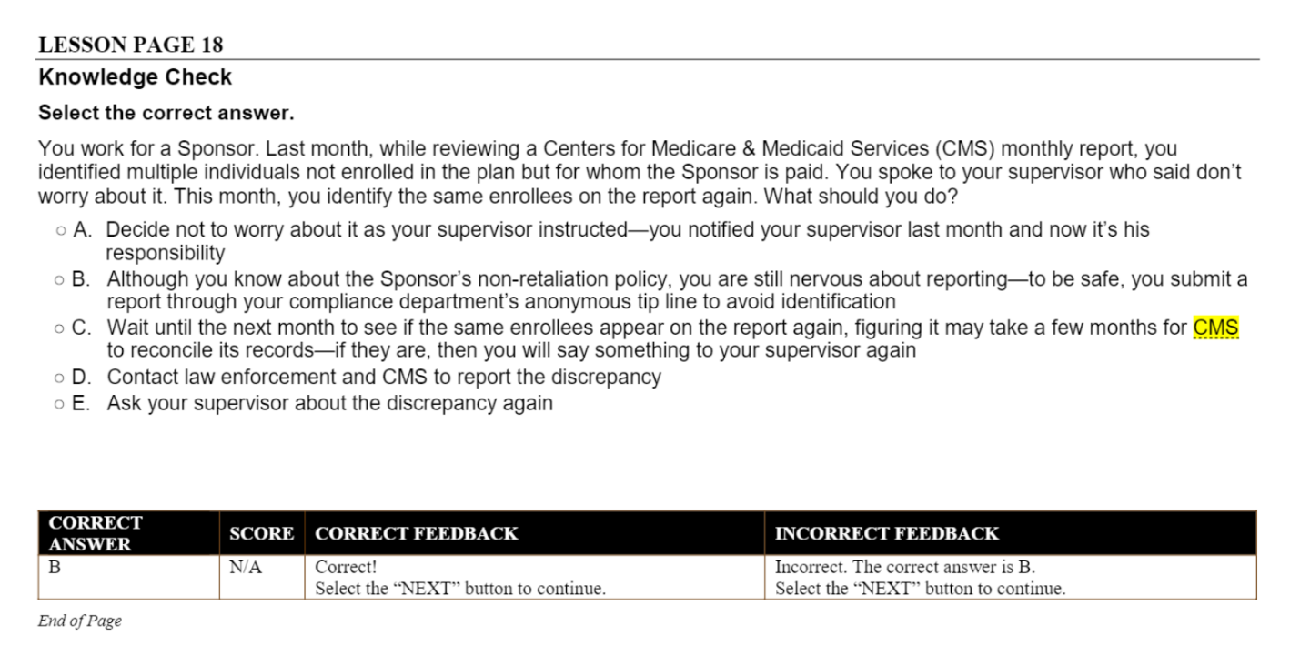

Machine generated alternative text:
You are performing a regular inventory of the controlled substances in the pharmacy. You discover a minor inventory discrepancy. 
What should you do? 
Call local law enforcement 
Perform another review 
Contact your compliance department (via compliance hotline or other mechanism) 
o 
E. 
Discuss your concerns with your supervisor 
Follow your pharmacy's procedures 
CORRECT 
ANSWER 
SCORE 
CORRECT FEEDBACK 
Correct! 
Select the "NEXT" button to continue. 
INCORRECT FEEDBACK 
Incorrect. The correct answer IS E. 
Select the "NEXT" button to continue. 

Machine generated alternative text:
Medicare 
Compliance programs help prevent, detect and correct noncompliance and fraud, waste and 
abuse. The Centers for Medicare and Medicaid Services (CMS) require that an effective 
compliance program include the seven core elements described below. They include: 
1. 
2. 
3. 
4. 
5. 
6. 
7. 
Written Policies, Procedures and Standards of Conduct 
Compliance Officer / Committee and High Level Oversight 
Effective Training and Education 
Effective Lines of Communication 
Well Publicized Disciplinary Standards 
Effective Systems for Routine Monitoring, Auditing and Identification of Compliance Risks 
Procedures and System for Prompt Response and Compliance Issues 
Click to review CMS Medicare Compliance and Fraud, Waste, and Abuse information: 
CMS Medicare Parts C and D General Compliance 
Combating Medicare Parts C and D Fraud, Waste, and Abuse 
Click this Ii 
As a reminder, CVS Health Medicare policies that support the Medicare Compliance Program 
are available on the CVS Health Policy and Procedure Portal, AetNet, and Aetna.com. 

Machine generated alternative text:
EXAMPLES 
A Medicare Part C plan in Florida: 
• 
Hired an outside company to review medical records to find additional diagnosis codes it could submit to 
increase risk capitation payments from CMS 
Was informed by the outside company that certain diagnosis codes previously submitted to Medicare were 
undocumented or unsupported 
Failed to report the unsupported diagnosis codes to Medicare 
Agreed to pay $22.6 million to settle FCA allegations 
The owner-operator of a medical clinic in California: 
• 
• 
Used marketers to recruit individuals for medically unnecessary office visits 
Promised free, medically unnecessary equipment or free food to entice individuals 
Charged Medicare more than $1.7 million for the scheme 
Was sentenced to 37 months in prison 

Machine generated alternative text:
Medicare Compliance Contacts 
If you identify actual or potential compliance, fraud, waste, or abuse concerns, it is your 
responsibility to report them. 
Chief Medicare Compliance Officer 
Patrick Jeswald 
Patrick.Jeswald@CVSHea Ith.com 
CVS Health Ethics Line* 
877-cvs-2040 
Ethics.BusinessConduct@CVS.com 
Confidential Fax: 1-847-559-3835 
Medicare Fraud Hotline (SilverScript Only) 
888-277-4149 
MedicareFraud@caremarkrx.com 
Aetna Special Investigations Unit 
800-338-6361 
AetnaSlU@aetna.com 

Machine generated alternative text:
SIU 
The Aetna Special Investigations Unit (Sl U) investigates suspected health care 
fraud, waste and abuse. They also report instances of suspected fraud to the 
appropriate federal and state agencies, including NBI MEDIC, OPM-OIG, and State 
Departments of I nsurance. For example, California requires us to report suspected 
fraud within sixty (60) days of when we determine that reasonable belief exists that 
insurance fraud may be or has been committed. (CIC 51872.4). Many other states 
have similar reporting requirements. 
To learn more about SIU, you can visit the SIU site. It contains links to the SIU 
Fraud, Waste and Abuse Manual, Sl U Contacts, and other valuable information. 
You can make reports anonymously by calling the CVS Health Ethics Line. All 
reports are handled in a confidential manner. Intimidation and retaliation are 
strictly prohibited. 

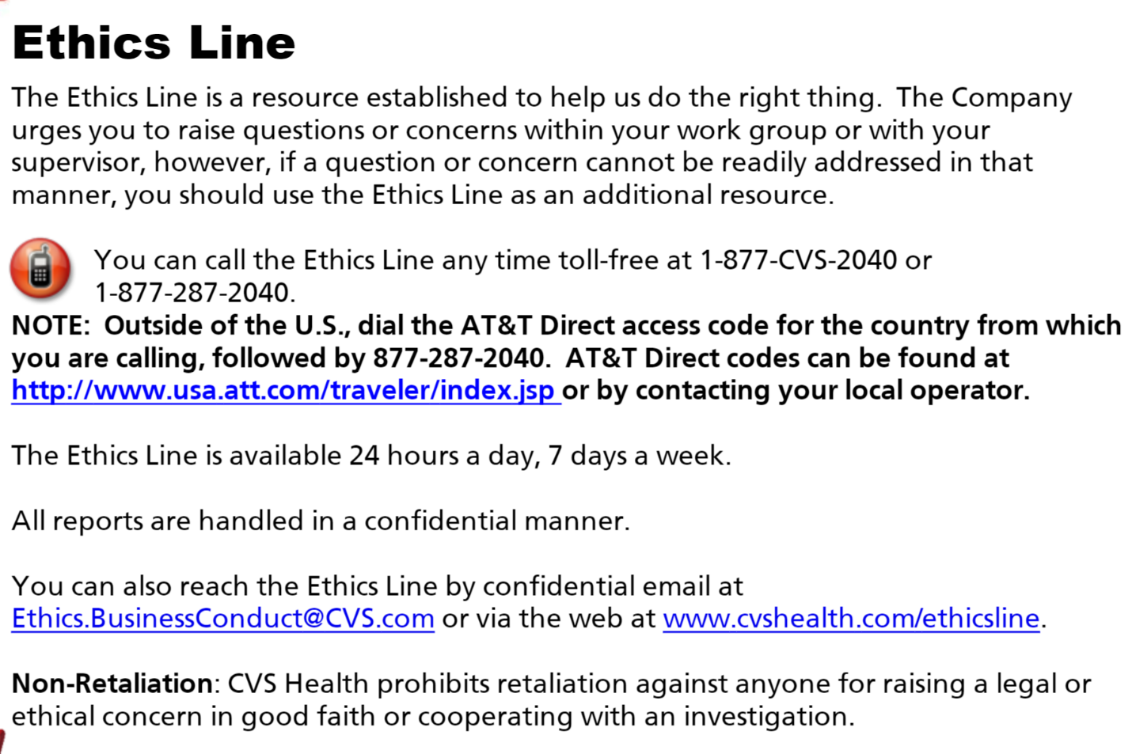

Machine generated alternative text:
Health Code of Conduct and Compliance Training 
Your Score: 
Passing Score: 
Results 
100% 
100% 
Result: 
Congratulations, you passed. 
Please select the survey link below to provide your feedback to help us improve this training. 
CVS Health Code of Conduct and Compliance Training 
After you complete the survey, please close this course window to exit the course. 

Machine generated alternative text:
Confidential & Proprietary Information 
You must: 
• Use this information only for job-related purposes and 
never for personal gain or to the detriment of CVS 
Health 
• Share proprietary information with co-workers only on 
a need-to-know basis 
• Not disclose information to persons outside the 
Company, including business associates or those we 
serve, except under the terms of a confidentiality 
agreement approved by the Legal Department 
• Return all proprietary information upon leaving 
CVS Health 
• Not share confidential and proprietary information 
learned from a prior employer 
• Share CVS Health policies and procedures only in 
accordance with our Distribution of CVS Health Policies 
and Procedures to PBM Clients and Other Third Parties, 
(CClG-048297) available on the Policy and Procedure 
Portal 